Assignment 4: Automatic EBS Snapshot and Cleanup Using AWS Lambda and Boto3

1. EBS Setup:
- Navigate to the EC2 dashboard and identify or create an EBS volume you wish to back up.
- Note down the volume ID.
vol-0e756617e37ca54c2
vol-0e756617e37ca54c2 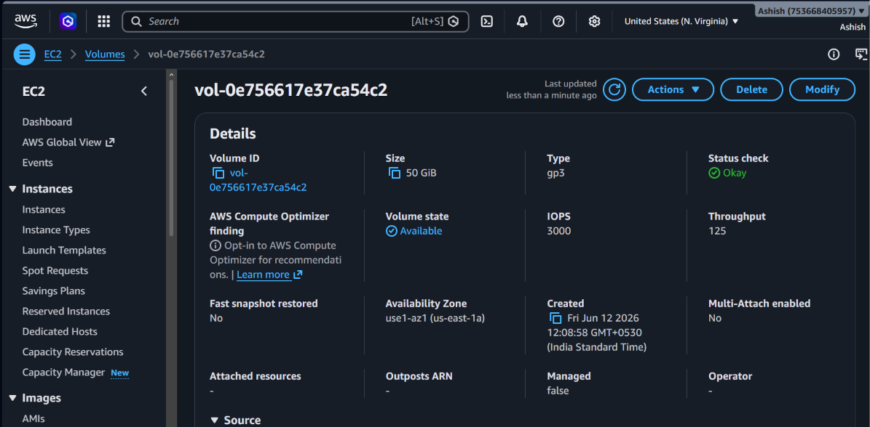

2. Lambda IAM Role: Role name : ebs-snap-ash1
- In the IAM dashboard, create a new role for Lambda.
- Attach policies that allow Lambda to create EBS snapshots and delete them (`AmazonEC2FullAccess` for simplicity, but be more restrictive in real-world scenarios).

Lambda function name : ebs-snap-lambda-ash1

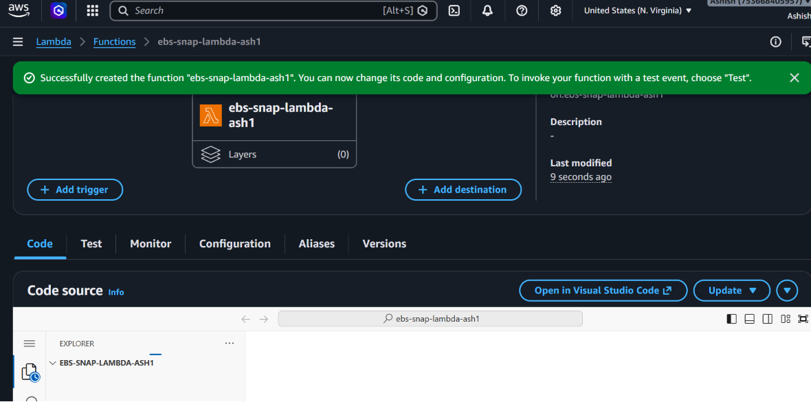

Function details:
import boto3
import datetime
import json

def lambda_handler(event, context):
ec2 = boto3.client('ec2', region_name='us-east-1') # adjust region
volume_id = ' vol-0e756617e37ca54c2' # replace with your EBS Volume ID
created_snapshot_id = None
deleted_snapshots = []

# Step 1: Create snapshot
snapshot = ec2.create_snapshot(
VolumeId=volume_id,
Description=f"Automated backup of {volume_id} on {datetime.datetime.now()}"
)
created_snapshot_id = snapshot['SnapshotId']
print(f"Created snapshot: {created_snapshot_id}")

# Step 2: Define cutoff date (30 days ago)
cutoff_date = datetime.datetime.now(datetime.timezone.utc) - datetime.timedelta(days=30)

# Step 3: List snapshots for this volume
snapshots = ec2.describe_snapshots(Filters=[{'Name':'volume-id','Values':[volume_id]}])['Snapshots']

for snap in snapshots:
snap_id = snap['SnapshotId']
start_time = snap['StartTime']

# Step 4: Delete old snapshots
if start_time < cutoff_date:
ec2.delete_snapshot(SnapshotId=snap_id)
deleted_snapshots.append(snap_id)
print(f"Deleted old snapshot: {snap_id}")

return {
'statusCode': 200,
'body': json.dumps({
'created_snapshot': created_snapshot_id,
'deleted_snapshots': deleted_snapshots
})
}

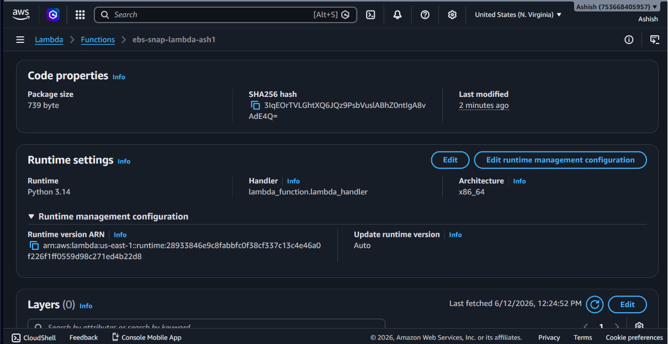

Test result:

